**Prediction of house prices and comparing the performances of different neural network regression techniques**

**ABSTRACT: House prices increase every year, so there is a need for a system to predict house prices in the future. House price prediction can help the developer determine the selling price of a house and can help the customer to arrange the right time to purchase a house.**

MODEL 1 (3 layer neural network):

Layer (type) Output Shape Param #

=================================================================

dense (Dense) (None, 32) 8416

_________________________________________________________________

dense_1 (Dense) (None, 16) 528

_________________________________________________________________

dense_2 (Dense) (None, 1) 17

Total params: 8,961

Trainable params: 8,961

Non-trainable params: 0

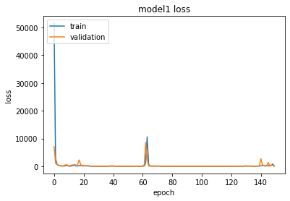

MODEL 2 (Keras regressor based) :

Layer (type) Output Shape Param #

=================================================================

dense_3 (Dense) (None, 32) 8416

_________________________________________________________________

dense_4 (Dense) (None, 16) 528

_________________________________________________________________

dense_5 (Dense) (None, 1) 17

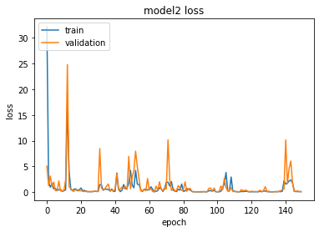

MODEL 3 (5 layer neural network):

Layer (type) Output Shape Param #

=================================================================

dense_6 (Dense) (None, 128) 33664

_________________________________________________________________

dense_7 (Dense) (None, 128) 16512

_________________________________________________________________

dense_8 (Dense) (None, 32) 4128

_________________________________________________________________

dense_9 (Dense) (None, 16) 528

_________________________________________________________________

dense_10 (Dense) (None, 1) 17

=================================================================

Total params: 54,849

Trainable params: 54,849

Non-trainable params: 0

